BASE24 and XPNET Overview
BASE24 Overview
- Processes:
  - XPNET
  - Device Handler
  - Authorization
  - Host Interface
  - Interchange Interface
- XPNET:
  - Handles message traffic
  - Provides process interface
  - Provides transaction integrity
  - Manages network configuration data
  - Performs auditing
  - Monitors data communications lines
- Device Handler
  - Formats messages
  - Performs error handling
  - Performs PIN decryption for software verification
  - Handles timing check on requests
  - Updates terminal totals
  - Performs surcharging checks
  - Handles receipt print option
  - Handles downline loads
- Authorization:
  - Routes transactions
  - Can authorize the transaction and update the customer files
    - Verifies
    - PIN
    - Card
    - Account
    - Usage
  - Logs transactions to TLF
  - Performs sharing checks
- Host Interface:
  - Formats messages
  - Performs host availability
  - Handles timing check on requests to host
  - Supports flexible ISO message contents
  - Controls store and forward (SAF) processing
- BASE 24 Modules:
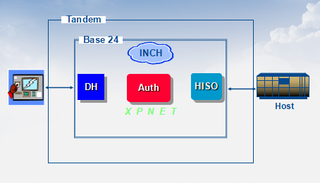

- Menu Structure:
- 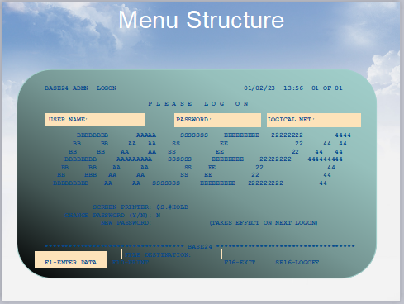
- 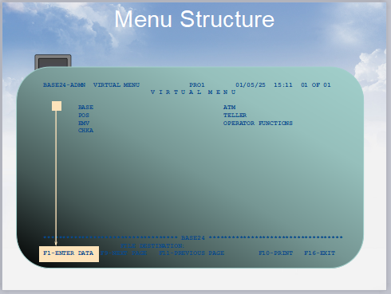
- 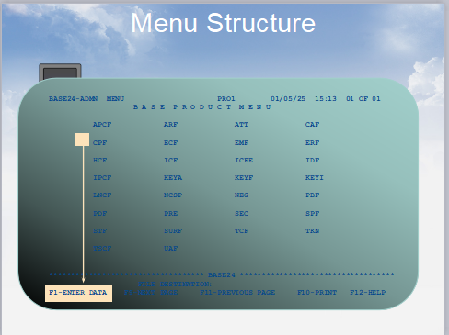
- 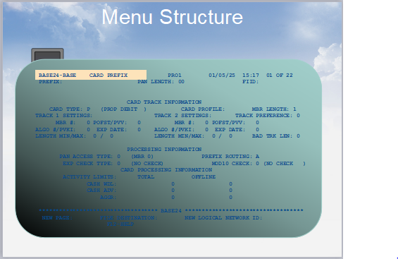
- Terminology:
- 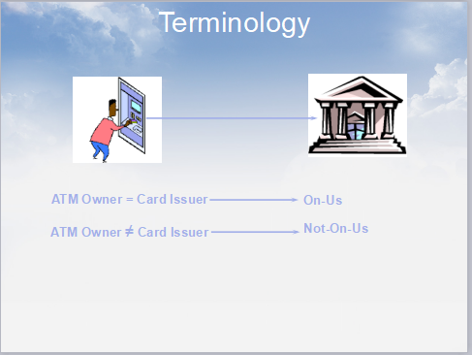
  - Onus Transaction
    - ATM Owner = Card Issuer
  - Not On-us (Offus Transaction/Remote Onus Transaction)
    - ATM Owner ≠ Card Issuer
- Terminology:
  - Online (Host Authorizes)
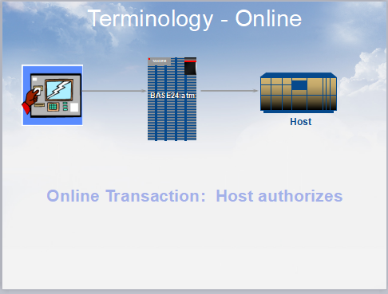
  - Offline (BASE 24 Authorizes)
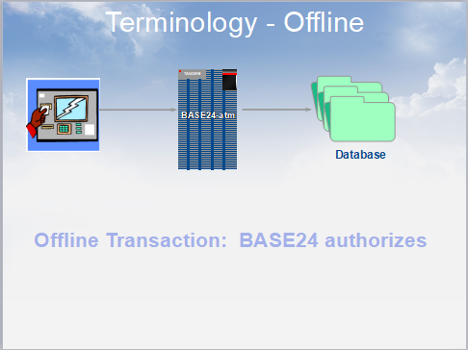
  - Online/Offline (Host Authorizes, BASE 24 Stand-in
- 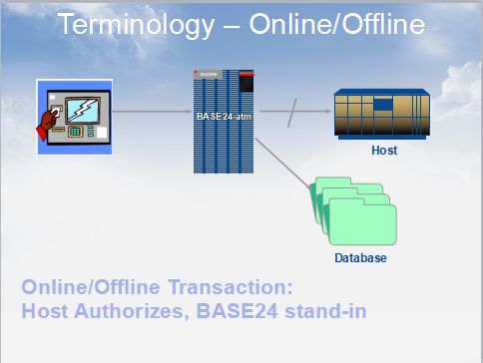

- Transaction Message Formats
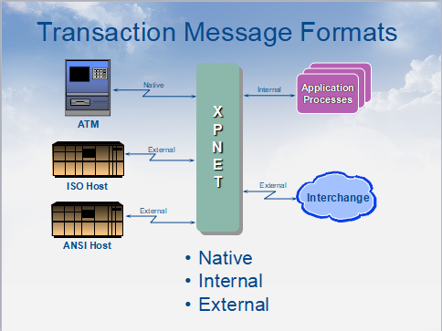
XPNET Overview
- What is an XPNET System?
  - An XPNET system provides the network management layer for BASE24 transaction processing
  - Serves as the software platform on which the application processes run
  - Provides functions for configuration and management of the network and its components
  - 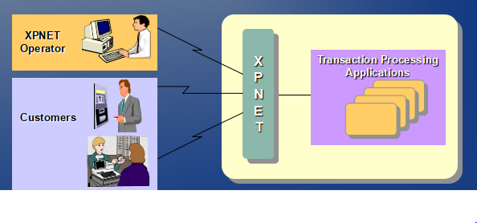
- XPNET Components
  - 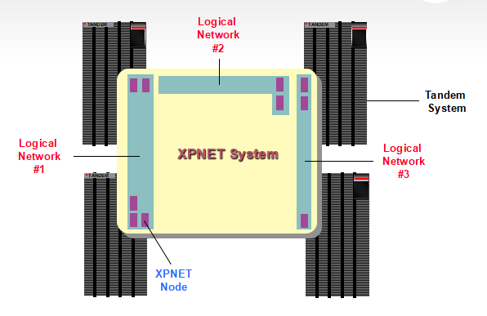
  - XPNET Node:
    - Consists of an XPNET process and the objects that it manages. These objects are nodes, lines, stations, application processes and links to other nodes.
    - 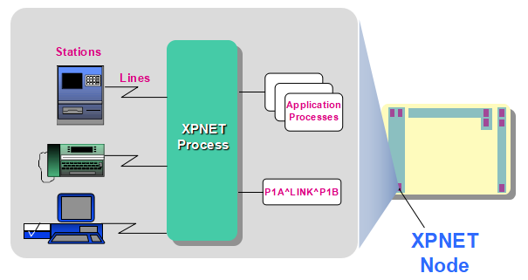
  - Logical Network
    - One or more XPNET nodes, acting as a single settlement entity, accessing a single database
    - 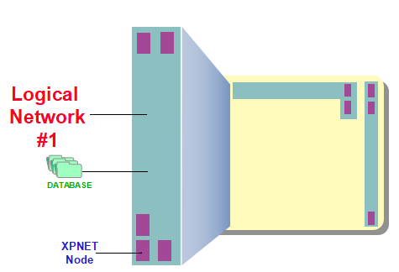
  - XPNET System
    - A structured network of one or more Logical Networks
    - 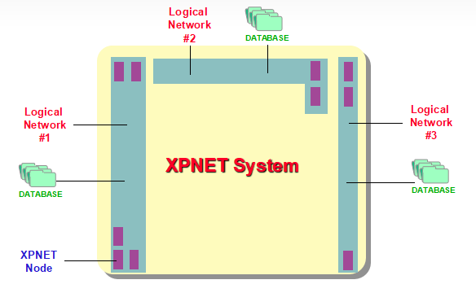
  - Tandem System
    - The physical Tandem computer
    - 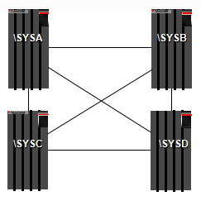
- XPNET Component Names
  - Objects and files can be given any valid name
  - Use of ACI naming conventions is not required, but is highly recommended to:
  - Help enforce uniqueness of object and file names
  - Provide a point of reference for discussing system components - (HELP24)
  - Tandem System Name
    - Identifies the Tandem system
    - Part of the fully qualified file name
    - First character must be a backslash
    - Up to 8 characters (including the backslash)
    - Examples:
      - \TANDEM
      - \SYS1
      - \K9
  - Volume Name
    - Identify disk volumes on which the system files reside
    - Part of the fully qualified file name
    - First character must be $, followed by an alphabetic character
    - Up to 8 characters (including the $)
    - Examples:
      - $SYSTEM
      - $BANK
      - $DATA1
  - XPNET System Name
    - Describes an entire XPNET system environment
    - Typically four alpha characters
    - First character must be a letter
    - First character must be unique if there will be multiple XPNET systems per Tandem system (PPD names)
    - ACI installers initially create a TEST system
    - Examples:
      - TEST
      - PROD
      - DVLP
      - CERT
  - Subvolme Names
    - Identify subvolumes on which various files reside
    - Part of the fully qualified file name
    - Up to 8 alphanumeric characters
    - May include:
      - XPNET system name
      - Logical network identifier
    - Examples:
      - TESTCNTL
      - TESTDATA (Network)
      - TES1DATA (Application)
      - TES1TPLT
  - File Names
    - Uniquely identifies the files defined to the system
    - May include:
      - Logical network identifier
      - XPNET node identifier
      - File identifier / Sequence number
    - Examples:
      - L1CONF
      - N1ANEF
      - CJ00000
  - Fully Qualified File Name
    - A fully qualified file name consists of:
    - Tandem System Name
    - | Disk volume name
    - | | Subvolume Name
    - | | | File Name
    - | | | |
    - \K9.$DATA1.TESTDATA.N1ANEF
  - Logical Network Configuration File
    - Contains file assignments and processing parameters for the logical network
      - Assigns relate file names to the physical location of that file
        - ASSIGN: SEC TO: \K9.$DATA1.AENVDATA.SEC
      - Params provide configurable processing parameters for the logical network
        - PARAM:
        - Name: LOGICAL-NET
        - Text: AEN1
  - Network Environment File
    - Objects that make up the XPNET node are defined in the Network Environment File (NEF)

Node | P1A^NODE
Processes | P1A^N50
Links | P1A^LINK^P1B
Devices | DEV^N50
Lines | L1A^N50A
Stations | S1AN50A1

  - XPNET File Structure
    - 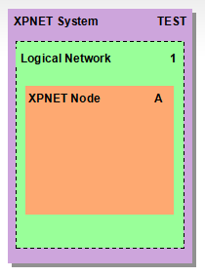
    - XPNET
      - NETWORK NETADRD NETCJRD NCPCOM NETDMPRD
    - TESTCNTL
      - GOAFT GOENTL GONCP GOPRE L1CONF PATHCOLD
      - PATHCONF PATHCOOL PATHCTL
      - PATHSTOP PATHSTRT PRECMD
      - SHUTDOWN STRTLOG
    - TESTDATA
      - N1ANEF NCSP NCSP
      - NCSS NMAP PREMAP
      - SPROUTE
    - TES1DATA : Application Files
    - TES1TPLT : Application File Templates
    - P1ANCJA : CJ00000 CJ00001
    - P1ANNOMA : NOM00000 NOM00001
  - Fully Qualifies Object Names
    - Fully qualified XPNET object names consists of:
      - Tandem System Name (Upto 8 characters including backslash)
      - | XPNET Node Name (Upto 16 alphanumeric characters)
      - | | Object Name
      - | | |
      - \K9.P1A^NODE.P1A^N50
    - Tandem System Name
      - Identifies the Tandem system
      - Part of fully qualified object name
      - First character must be a backslash
      - Up to 8 characters (including the backslash)
      - Examples:
        - \TANDEM
        - \SYS1
        - \K9
    - XPNET Node Name
      - Identifies the XPNET Node
      - Part of fully qualified object name
      - Up to 16 alphanumeric characters
      - Examples:
        - \K9.P1A^NODE
        - \K9.P1B^NODE
        - \K9.P1C^NODE
    - Object Name
      - A Symbolic name that uniquely identifies each object in the XPNET node
      - Up to 16 alphanumeric characters
      - May include:
        - Object type indicator
        - Logical network identifier
        - XPNET node identifier
        - Separator ( optional ^ or - )
        - Object description
      - Examples:
        - \K9.P1A^NODE.P1A^N50
        - \K9.P1A^NODE.L1A^N50A
        - \K9.P1A^NODE.S1AN50A1
    - PPD Names
      - PPD names identify a process pair
      - Name must be unique on the Tandem system
      - First character must be a $, followed by up to 4 characters
      - May include:
        - First character of XPNET system name
        - Logical network identifier
        - XPNET node identifier
        - Copy number
      - Examples:
        - $T1AN $TPMN $T1AU $TAT1
- XPNET Functions
  - XPNET Process
    - The controlling process for the XPNET node responsible for:
      - Driving the data communications lines
      - Controlling all lines, stations and processes in the XPNET node
      - Routing messages
      - Managing message queues
      - Running system audits
      - Communicating with other XPNET processes
      - Monitoring the performance of the system
      - Enabling continuous processing
  - Object Management
    - The XPNET process manages the objects in the XPNET node, as defined in the NEF
    - Object management
      - Startup
      - Recovery
      - States
  - Object Startup:
    - XPNET manages the starting of the objects in the XPNET node
    - XPNET can start objects based on the following table:
 | Startup Attribute
Object Type | Automatic | Command | Demand
Node | X | X
Process | X | X | X
Link | X | X

  - Object Recovery
    - The XPNET process can be configured to provide fault tolerant processing by:
      - Existing on multiple CPUs
      - Running multiple copies of critical application processes on different CPUs
    - XPNET process checkpoints with its backup in one of two ways
      - Hot
      - Warm
  - Object Machine States
    - An XPNET object may be in one of seven states defined by its readiness to perform its function:
      - Starting
      - Started
      - Stopping (not Links)
      - Stopped
      - Abnormal
      - Suspended (Stations only)
      - Disabled
  - Message Routing
    - The XPNET process routes messages to:
      - Application processes in the XPNET node
      - Other XPNET nodes
      - Stations outside of the XPNET system
        - Hosts
        - Interchanges
        - Terminals
        - Other endpoints
  - Types of Message Routing
    - Types of message routing:
      - Symbolic
        - Message routed based on symbolic name specific destination
DESTINATION = P1A^N50A
      - Service based
        - Message routed based on the service that it requires
SERVICE = AUTH
  - Message Queue Management
    - Message queue management
      - Provides a means of monitoring and managing messages queued to object
    - User configured limits
      - Queue Alert Threshold
      - Queue Management Threshold
      - Queue Management Index
  - Network Overload Management
    - When Network Overload Management actions are taken, a message may be:
      - Added to the queue
      - Returned to its source
      - Saved to disk
      - Discarded
  - Event Logging
    - Provides logging of events generated by XPNET or and of its objects
    - Used in detecting and resolving system problems
LOG LCT: 01-02-15 LOG LCT: 16:30:00.505 EVT NR: 485
SENDER: \R.$SPS1 SSID: ACI.590.1000
GENERATOR: P1B^PSETL1
MGR: \R.$S1BN Retailer RET01 has been cutover to
010216
  - Command and Control
    - Operator commands provide the syntax for operators to modify or query the system
    - Three types of operator commands:
      - Environment commands
      - Inquiry commands
      - Object management commands
  - Command and Control Facilities
    - Open Network Control Facility (ONCF) is the component of XPNET providing the command and control interface to the XPNET system
    - Two standard forms of user interface provided
      - NCS
      - NCPCOM
  - NCS
    - Requires application logon to BASE24 Pathway
    - Accessed from Operator Function menu
    - Preformatted screen for command entry and response display
    - 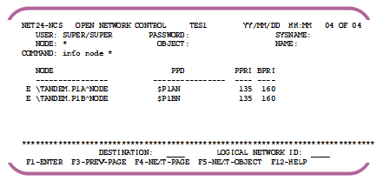
  - NCPCOM
    - Started from TACL
    - Interactive prompt for command entry
    - 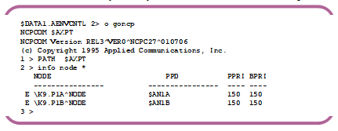
  - Network Control Security
    - XPNET provides security measures to limit access by command and to optionally audit commands initiated
      - By node
      - By operator
      - By command
  - Message Auditing
    - XPNET provides an auditing facility for tracing message traffic between the XPNET process and designated stations and processes
    - Used to detect and diagnose problems in transaction processing

- XPNET
    - The name XPNET is likely derived from its core functionality in transaction processing and network management within BASE24 systems. Though there is no officially documented full form, the name can be broken down as follows:
    - XP: Possibly refers to "Exchange Processing" or "Extended Processing", indicating its role in handling financial transactions and routing.
    - NET: Stands for "Network", as XPNET is primarily responsible for managing communication between ATMs, POS terminals, and host banking systems.
    - XPNET is a network management and communication framework used in BASE24 systems to handle transactions between ATMs, POS terminals, and banking hosts.
    - It is responsible for routing, switching, and monitoring financial transactions in a secure and efficient manner.
    - Key Functions of XPNET:
      - Transaction Routing & Switching:
        - Routes transaction messages (e.g., cash withdrawals, balance inquiries) between ATMs, POS terminals, and banking networks.
        - Supports multiple communication protocols, including TCP/IP, X.25, and SNA.
      - Network Management:
        - Monitors and manages communication links between devices and host systems.
        - Ensures high availability and fault tolerance in transaction processing.
      - Protocol Conversion:
        - Converts messages between different network protocols (e.g., ISO 8583 over TCP/IP).
        - Helps in seamless integration with different banking networks.
      - Security & Encryption:
        - Ensures secure communication of transaction data.
        - Works with cryptographic modules for PIN encryption and secure data transmission.
      - Real-time Monitoring & Logging:
        - Provides logging and tracking of transactions for auditing and troubleshooting.
        - Generates alerts for failed or suspicious transactions.
    - How XPNET Works in BASE24?
      - ATMs & POS terminals send transaction requests (like withdrawals or balance checks).
      - XPNET receives the request, routes it to the appropriate processing system (BASE24 host or interbank network).
      - BASE24 processes the request and sends a response back through XPNET.
      - XPNET ensures message delivery and maintains session integrity using protocols like TCP/IP.

